Spring vs Spring Boot

Spring is a framework.
Spring Boot is Spring with intelligence, automation, and defaults.
Spring Boot did not replace Spring.
It removed configuration pain from Spring.

What is Spring Framework ??
Spring is an enterprise application framework built around two core principles:
• Inversion of Control (IoC)
• Dependency Injection (DI)

Without Spring:
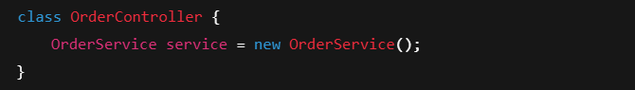This creates:
• Tight coupling
• Hard to test
• Hard to replace
With Spring:
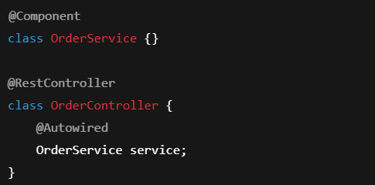

“How Spring internally works around DI + IoC”
ApplicationContext
→ scans beans
→ creates objects
→ wires dependencies
→ manages lifecycle

This gives:
✔ Loose coupling
✔ Easy mocking
✔ Replaceable implementations
This is why Spring became the standard for enterprise Java.

What problems Spring solved ??
Before Spring:
• EJB
• Heavy servers
• Huge XML
• Tight coupling
• No unit testing
Spring fixed this by:
• Using POJOs
• Using DI
• Using annotations
• Supporting testing
But Spring didn’t stop there.
It built powerful modules on top of DI:
Module | What it does
Spring JDBC | Simplifies database access
Spring ORM | Integrates Hibernate & JPA
Spring MVC | Web & REST APIs
Spring AOP | Logging, transactions, security
Spring JMS | Messaging
Spring Test | Testing

Why Spring JDBC exists ??
Traditional JDBC:
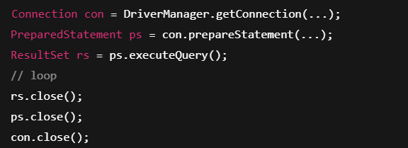Spring JDBC:
Same database.
Less plumbing.
More testable.
Spring modules don’t add new features.
They remove boilerplate and coupling.

Why Spring apps became painful ??
To build a Spring web app you needed:
• DispatcherServlet
• ComponentScan
• ViewResolver
• Web.xml
• DataSource
• Hibernate
• TransactionManager
A simple REST API needed 100+ lines of config.
This is where Spring Boot enters.

What is Spring Boot ??
Spring Boot is Spring + Auto Configuration + Embedded Server + Starters
Spring Boot focuses on:
• Speed
• Convention
• Automation
You write:
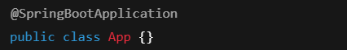
Boot:
• Creates ApplicationContext
• Scans beans
• Configures MVC
• Configures Tomcat
• Configures JSON
• Configures JPA
• Starts server
You write zero XML.

What is Auto-Configuration ??
Spring Boot checks:
“What jars are on the classpath?”
If it sees:
• spring-web → configure DispatcherServlet
• spring-data-jpa → configure Hibernate
• jackson → configure JSON
• tomcat → configure server
This happens because of:
@EnableAutoConfiguration
You can override anything.
Boot just gives smart defaults.
Example: DataSource auto-config
Without Boot:
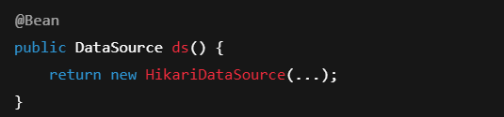
With Boot:
Add this in application.properties:
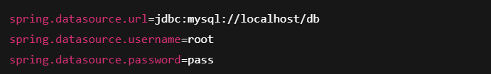Boot creates DataSource automatically.

What are Starters ??
Instead of adding 10 dependencies, you add one: spring-boot-starter-web
It pulls:
• Spring MVC
• Jackson
• Tomcat
• Validation
And auto-configures everything.

Spring vs Spring Boot
Spring | Spring Boot
Framework | Framework + Automation
Needs XML & beans | Zero config
External server | Embedded server
Manual wiring | Auto-configuration
Slow setup | Fast startup
Interview Killer Line
“Spring Boot is Spring with opinionated defaults that remove infrastructure setup.”

Spring solved:
• Object creation
• Dependency management
• Enterprise architecture
Spring Boot solved:
• Configuration hell
• Startup complexity
• Deployment friction
Spring is power.
Spring Boot is speed.

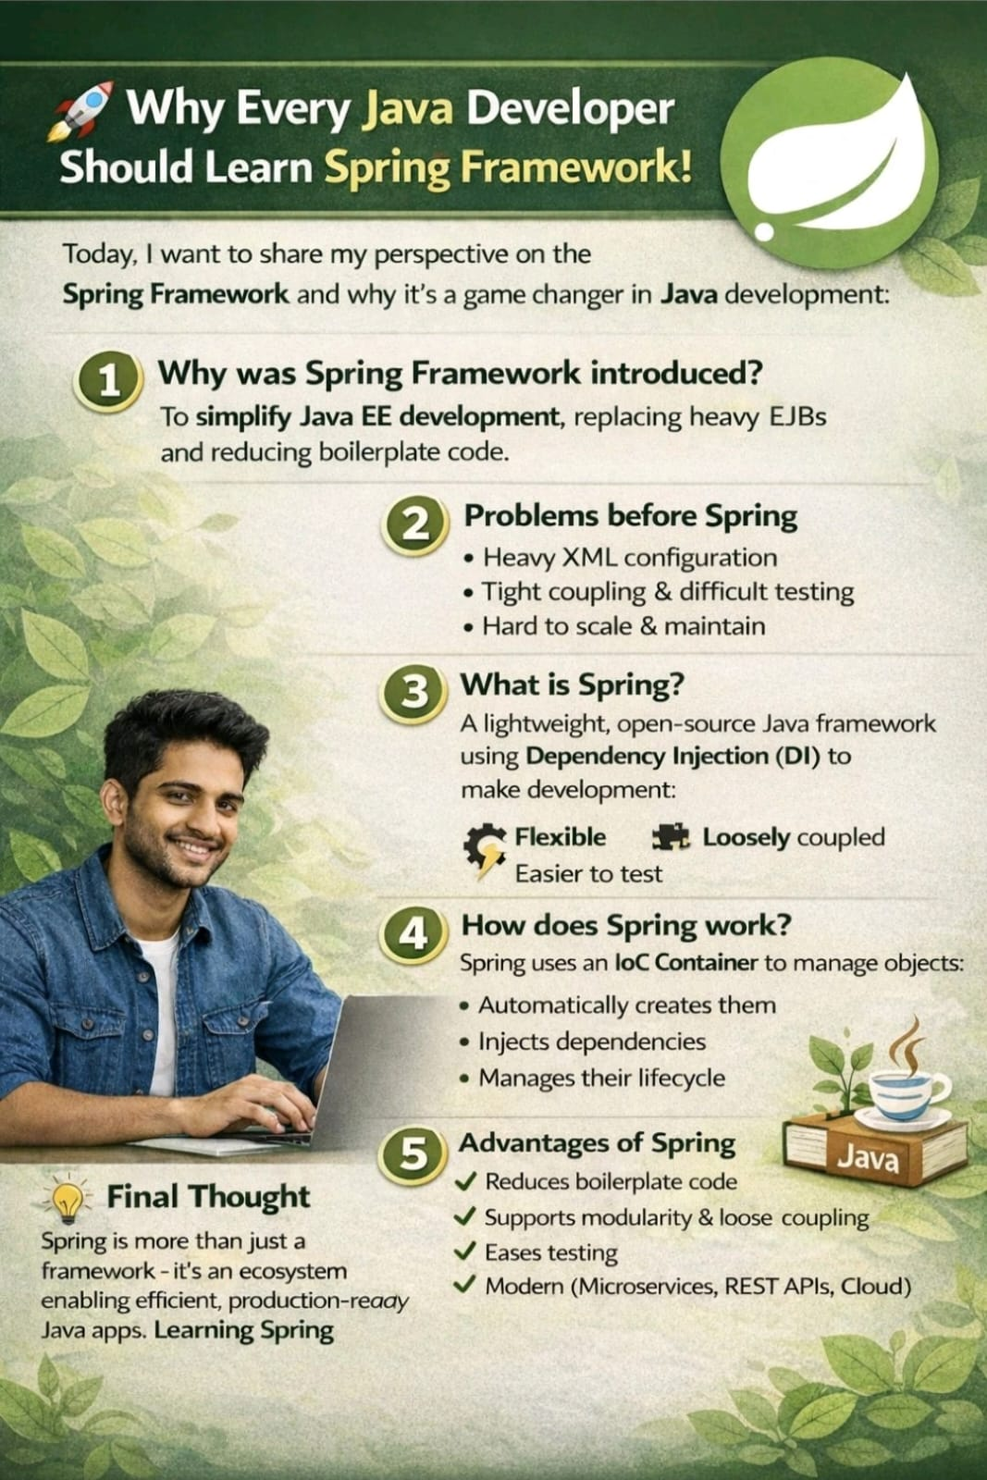
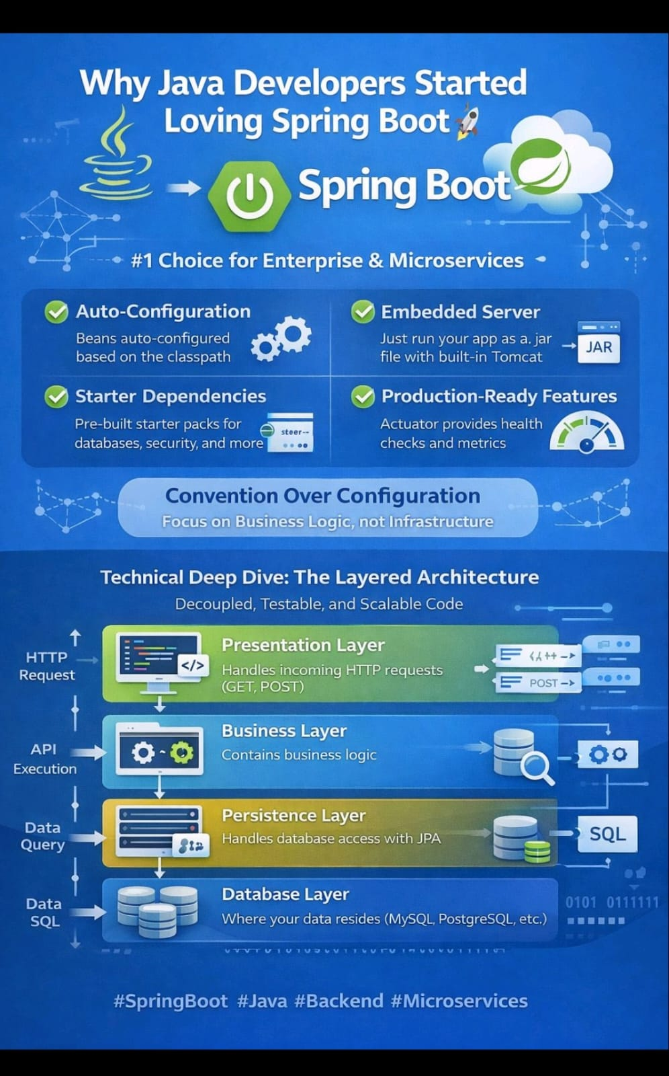

Summary

How Spring Actually Works Behind the Scenes (The Engine You Don’t See)

Spring is not magic.
It is an object factory with a brain.

When a Spring application starts, the first thing that comes alive is not your Controller, not your Service, not your Repository — it is the Spring Container (ApplicationContext).

This container does four critical things:
- It scans your application for classes annotated with @Component, @Service, @Repository, @Controller
- It creates objects for those classes
- It figures out how those objects depend on each other
- It wires them together into a complete object graph

That means your application is not a random collection of Java objects — it is a managed dependency graph created and owned by Spring.

Without Spring, object creation looks like this:
OrderService service = new OrderService();
PaymentService payment = new PaymentService();
service.setPaymentService(payment);

Every class decides what it depends on.
Every class creates its own collaborators.
This is tight coupling.

With Spring, object creation is inverted:
@Service
class OrderService {
@Autowired
PaymentService paymentService;
}
Now:
- OrderService does NOT decide what PaymentService is
- Spring decides
- Spring creates
- Spring injects
This is Inversion of Control.

Dependency Injection is simply how IoC is implemented.
The result is:
- Classes depend on abstractions
- Object wiring happens outside the class
- Code becomes testable
- Code becomes replaceable
- Architecture becomes flexible
This is why Spring is an enterprise framework — not because of annotations, but because of control over object graphs.

Spring Was Not Built to Replace Technologies — It Was Built to Orchestrate Them
Spring never tried to replace databases, ORMs, web servers, or testing frameworks.
It did something far more powerful.
It became the glue layer between them.
Hibernate is great at ORM.
JUnit is great at testing.
Tomcat is great at serving HTTP.
JDBC is great at talking to databases.
Spring does not compete with them — it integrates them.
Spring uses:
- Hibernate for ORM
- JUnit + Mockito for testing
- Tomcat for HTTP
- JDBC for database access
But Spring controls how they are wired together using Dependency Injection.
This is why Spring became dominant in enterprise Java — not because it reinvented technology, but because it orchestrated complexity.

Why Spring MVC Exists
Before Spring MVC, Java web apps were built using Servlets and JSPs.
Everything was tied together:
- URL parsing
- Request handling
- Business logic
- View rendering
Spring MVC introduced:
- DispatcherServlet (front controller)
- Handler mapping
- Controller classes
- View resolvers
This separated concerns:
Request → Controller → Service → View
This decoupling made large web applications manageable.

Why Spring Applications Became Painful to Build
As powerful as Spring was, it had a serious problem:
Configuration Explosion
A real Spring application required:
- DataSource
- EntityManagerFactory
- TransactionManager
- ComponentScan
- DispatcherServlet
- ViewResolver
- Jackson converters
- Security filters
- And dozens of XML or Java configs

Every project started with hundreds of lines of infrastructure wiring before a single API was written.
Spring solved architecture — but not developer experience.
That is where Spring Boot enters.

What Spring Boot Actually Does
Spring Boot did not change Spring’s core.
It changed how Spring is configured.
Spring Boot looks at:
- What JARs are on the classpath
- What dependencies you added
- What beans already exist
And then it decides what to create automatically.
This is called Auto-Configuration.
If Spring MVC is on the classpath →
Spring Boot creates:
- DispatcherServlet
- JSON converters
- Default error handlers
If Hibernate is on the classpath →
Spring Boot creates:
- DataSource
- EntityManagerFactory
- TransactionManager
If no DataSource is defined →
Spring Boot creates a default one.
But if YOU define one →
Spring Boot backs off.
This is how Spring Boot is smart.
It uses conditions like:
- @ConditionalOnClass
- @ConditionalOnMissingBean
This is how it knows when to auto-configure and when not to.

What Starters Really Do
Spring Boot starters are not just dependency bundles.
They encode:
- Which libraries belong together
- Which versions are compatible
- Which auto-configurations should trigger
Instead of manually finding:
- Spring MVC
- Jackson
- Validation
- Tomcat
- Logging
You just write:
spring-boot-starter-web
Boot does the rest.
This removed dependency hell from Java backend development.

Spring Boot Is Not a Replacement — It Is the Evolution
Spring = Enterprise Architecture Framework
Spring Boot = Application Platform on top of Spring
Spring gives you:
- DI
- IoC
- MVC
- ORM
- AOP

Spring Boot gives you:
- Auto-configuration
- Starters
- Embedded servers
- Opinionated defaults
- Zero-XML setup
Spring Boot did not change what Spring does.
It changed how fast and safely you can use Spring.
That is why today:
Every modern Spring project is a Spring Boot project.
Because in enterprise systems:
Architecture matters.
But velocity matters even more.

